**EXPERIMENT : 6**

**E TICKET BOOKING**

USE CASE DIAGRAM

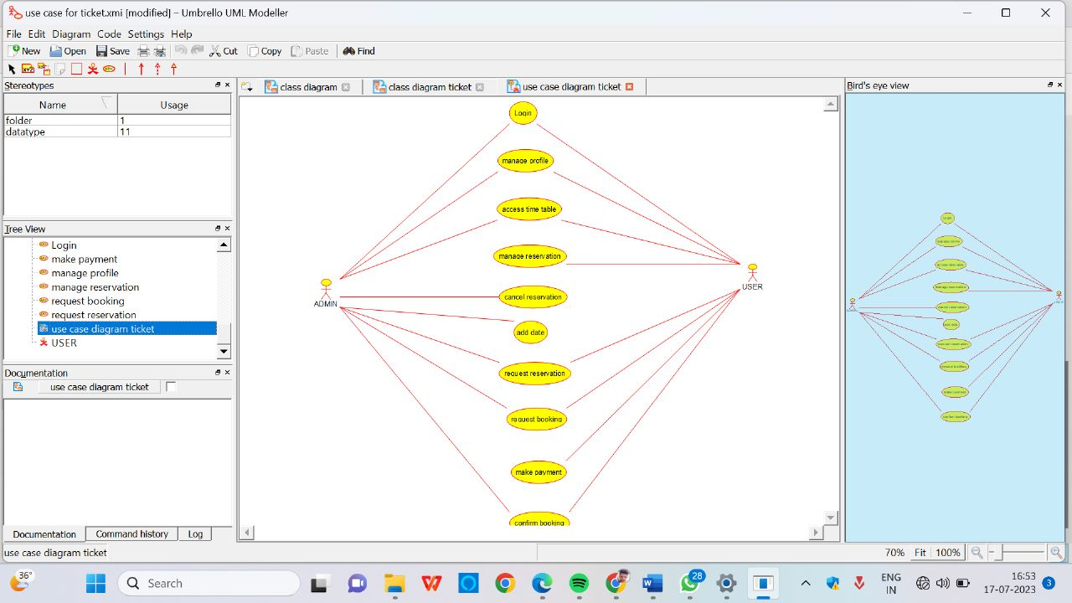

SEQUENCE DIAGRAM

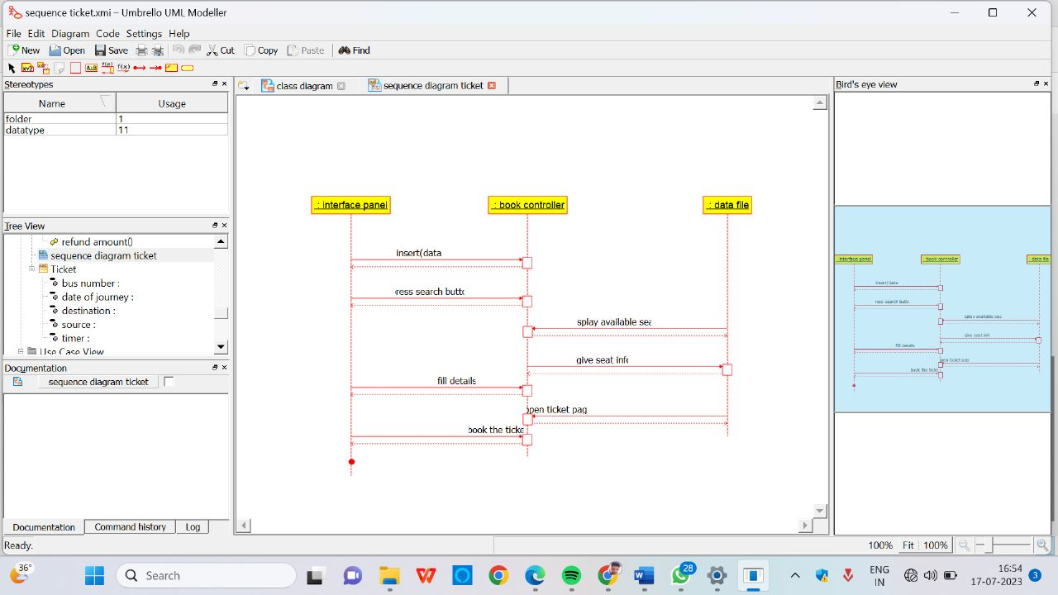

CLASS DIAGRAM

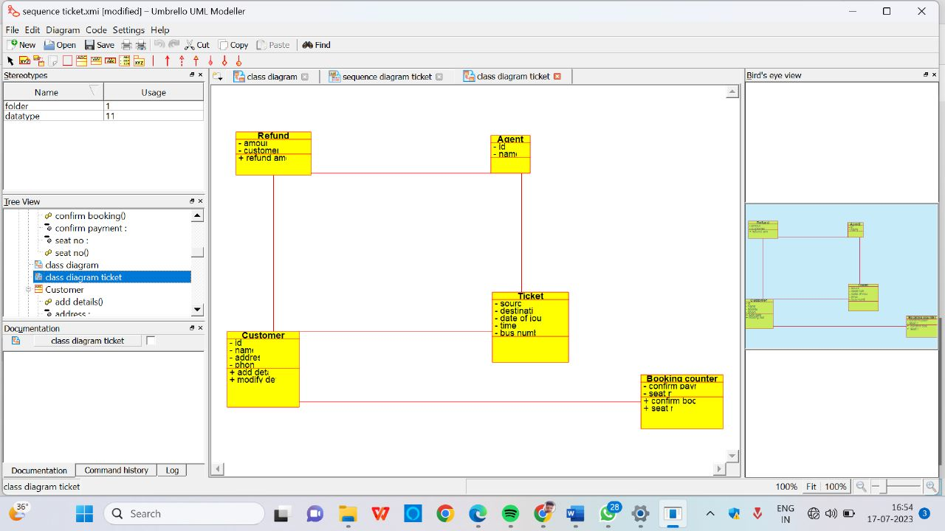

ACTIVITY DIAGRAM

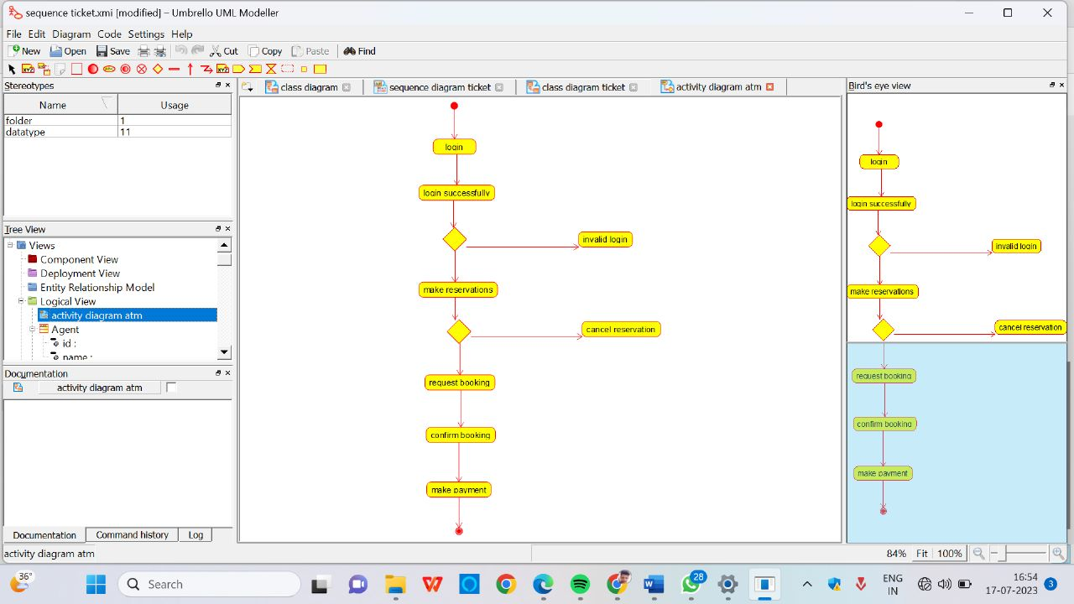

COLLABARATION DIAGRAM

